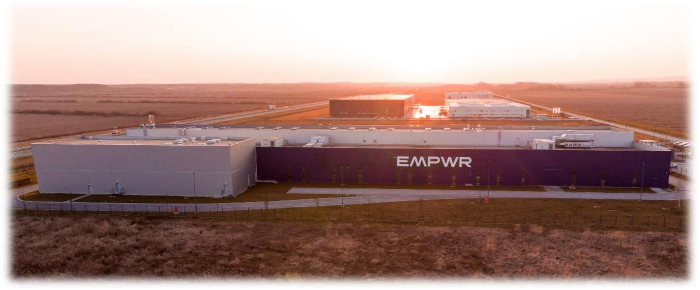

Request for Proposal IT Service Partner

- Introduction 3
  - EMPWR Organization & Structure 3
  - Purpose of RFP 4
  - General Instructions for respondents 4
  - Confidentiality Notice 5
- Partnership Objectives 5
  - Current IT Landscape 5
  - Internal IT Team 6
  - Scope of the service 7
- RFP 10
  - RFP Process & Rules 10
  - Provisional Timetable 11
  - Correspondence & Contacts 11
  - Price & Quotation 12
  - References 12
- Requirements 12
  - Services 12
  - Technology 12
  - Global versus Local 13
  - Tooling 13
  - Partnerships 13
- Addendum A: Technology Facts & Numbers 14
  - Endpoint Devices / IT Users 14
  - Networking (FortiNet) 14
  - Cloud Servers (Azure) 14
- Terms & Conditions 15

Introduction

EMPWR (empwrnutrition.com) is a Belgian based global manufacturer of nutrition bars with manufacturing plants in the Netherlands, Croatia, the USA and Canada.
EMPWR works as a co-developer and contract manufacturer for many leading and fast-growing brands in Europe and North America. EMPWR has grown from 160 to 1600 employees globally over the past 5 years and has the ambition to continue this strong growth over the next years. Headquarters are based in Ghent, Belgium.

EMPWR Organization & Structure

Organizational Structure

EMPWR is organized by regional Business Units and global Business Functions.
- Business Units Europe and the Americas execute through sales and operations.
- Global Business Functions provide standards and support.

IT is part of the global Business Function Transformation, reporting to the Chief Transformation Officer (CTO)
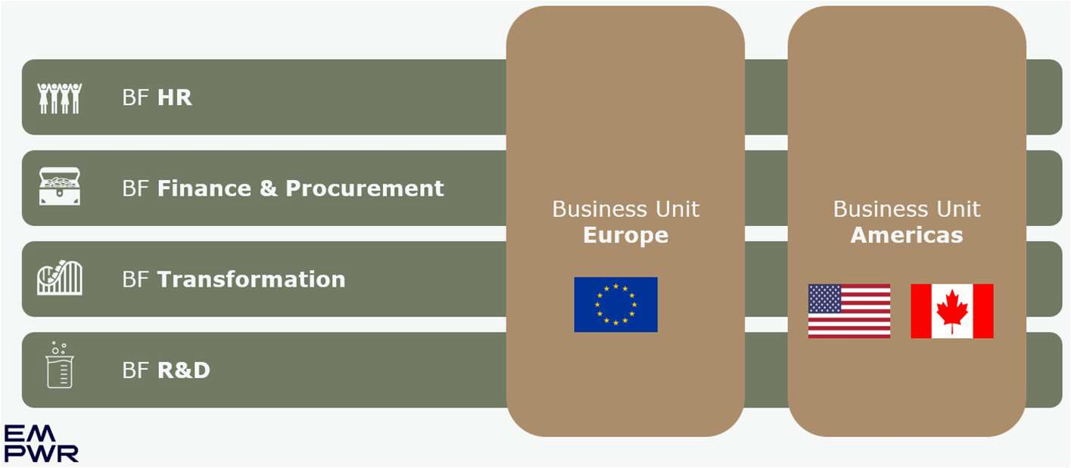

Locations, functions and employees

In total, EMPWR employs approximately 1.700 people (75% blue collar workers) and we are active in the following locations:
  - Ghent, Belgium
    - Headquarters
  - Leerdam, The Netherlands
    - Production & Logistics
  - Nova Gradiska, Croatia
    - Production & Logistics
  - Zagreb, Croatia
    - Administrative Office
  - McMinnville (Oregon), United States
    - Production & Logistics
  - Salem (Oregon), United States
    - Warehouse & Logistics
  - Montreal, Canada
    - Production & Logistics

Purpose of RFP

The purpose of this Request for Proposal (RFP) document is to:
- Share EMPWR’s service, technology and geographical requirements with service provider candidates.
- Gather information on providers service model, technology capabilities and pricing plans.
- Select a limited number of candidates for on-site Q&A sessions No contract award will be made based solely on RFP responses.

General Instructions for respondents

- Submit any clarifying questions by 13-Mar2026 CoB via email to bart.hoet@empwrnutrition.com.
- Provide your completed response in editable format (Word / Excel).
- All prices must be quoted in EUR, excluding VAT.
- Keep marketing material to a minimum; focus on factual answers.

Confidentiality Notice

All material and information provided by EMPWR must be regarded as confidential. Likewise, all information contained in your response will be treated as confidential. This information will only be made available to the team members assisting in the evaluation process. By accepting this document, vendors agree not to disclose any part of its contents to third parties without EMPWR’s prior written consent.

Partnership Objectives

Current IT Landscape

EMPWR supports approximately 650 IT end-users within a cloud-smart IT environment.

- Microsoft 365 forms the foundation of the digital workplace, with core collaboration, productivity & security services provided through Microsoft Exchange Online, SharePoint Online, Teams, OneDrive for Business, Microsoft Office applications and Defender & EMSE5 security features.

- Microsoft Azure is used as the primary platform for both IT and OT identity, infrastructure and application services. Approximately 40 virtual servers are hosted across Azure regions in the EU and the US. The on-premises footprint is very minimal and limited to essential (OT) components only and end user equipment.

- Network connectivity is fully based on Fortinet technologies, utilizing FortiGate firewalls, FortiSwitch infrastructure, FortiAP wireless access points, FortiEMS, FortiAnalyzer and FortiManager.

Out of scope for the current RFP, included to provide context regarding the broader IT landscape.
- SAP is our main ERP application across the group. This is a ECC6 platform running on Azure, with following modules in use: FI-CO, MM, QM, IM, WM, PP, SD. A migration to S4/Hana is on the strategic roadmap.

- EMPWR leverages Microsoft Power BI and Microsoft Fabric as its data and analytics platform for reporting and analytics.

- EMPWR has a variety of local business applications, primarily managed by our sites locally. This includes systems to support HR management, training, recipe management, plant maintenance, CRM, etc. A migration to global applications at group level is part of the strategic roadmap.

- Our Operations Technology environment at the various sides consists primarily of label printing solutions, handheld RF scanners (linked to SAP) and recently we started the deployment of an MES system (Siemens OpCenter / InsightsHub) to reduce the manual and paper-based way of working in our manufacturing facilities.

Internal IT Team

EMPWR has an internal IT team of 20 employees organized by technology domain, of which 12 based at HQ in Belgium and 8 at the various sites.
Following diagram represents key capabilities by IT domain.
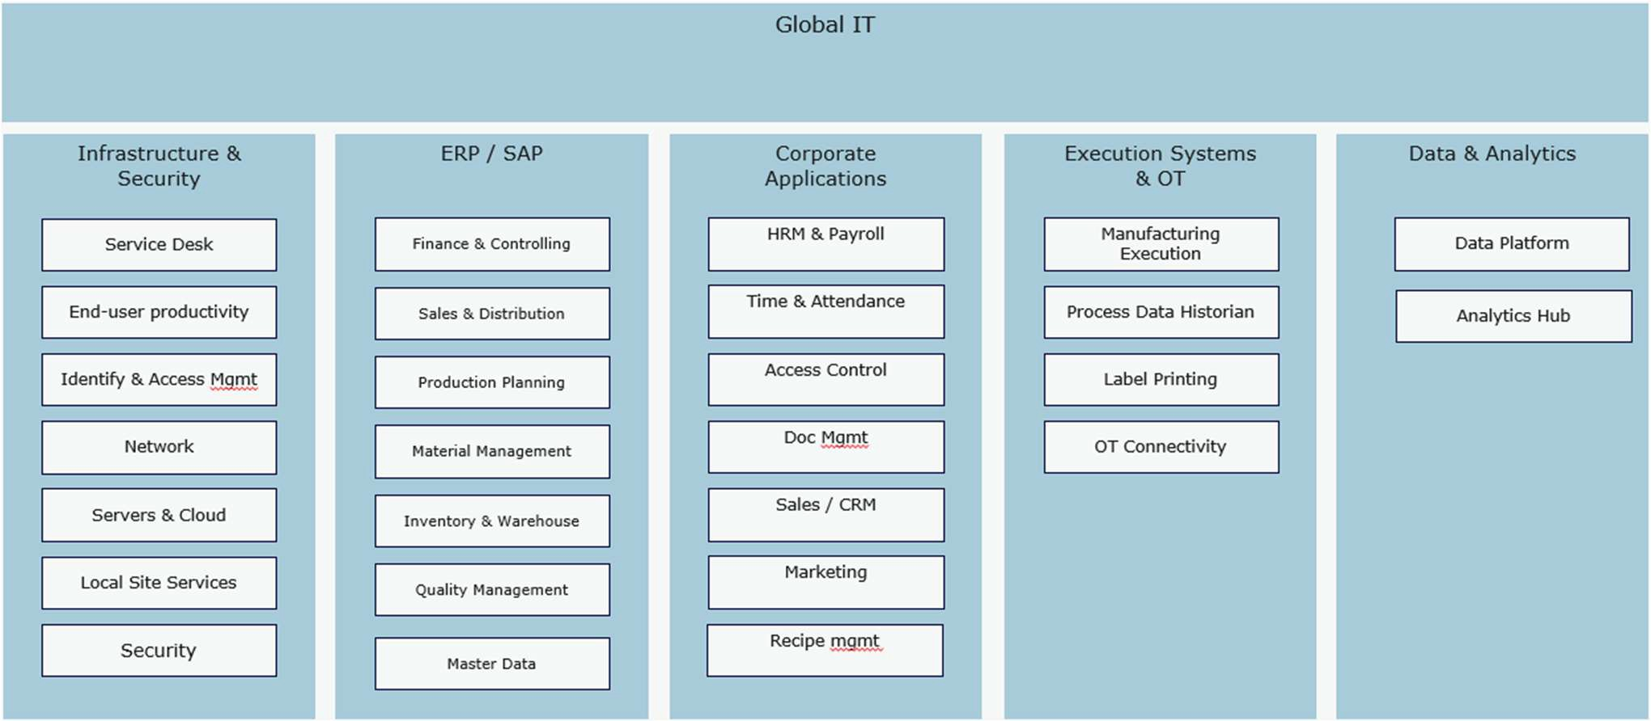

The IT infrastructure and security team consists of the following roles:
- The Global IT Manager Infrastructure & Security, who will overlook this IT Service Partnership
- 1 IT engineer per country (except Canada). This role is responsible for overseeing and executing day-to-day IT operations, including performing standard changes, providing second-line end-user support, and coordinating with local vendors & local stakeholders among other operational duties.

Scope of the service
The scope of the service covers the end‑to‑end delivery, co-management, and continuous improvement of IT services that support EMPWR’s business & production operations.

The selected partner will be responsible for providing reliable, secure, and scalable services aligned with EMPWR’s IT strategy, EMPWR’s governance model, security policies and delivered according to ITIL-based service management best practices.

The service scope includes, but is not limited to, the following core areas:
- General service management
- Incident, Problem and Change management
- Secure Network & Connectivity Services
- Infrastructure & Platform services
- Security Services
- Workplace & end-user services
- Communication & collaboration services

General Service Management
The selected partner is responsible for the overarching coordination, delivery, and operational management of all in-scope IT services, ensuring stable, secure, and high‑quality service delivery. The partner must operate according to ITIL‑based service management best practices, including the provision of a clear and comprehensive service catalogue, robust service design, effective service desk, service level and service delivery management, structured incident and problem management, and a strong focus on continuous improvement across all services and processes.

Incident, Problem and Change management
The selected partner is responsible for service desk operations. This includes first line (catch & dispatch) across the various IT domains for all EMPWR sites globally and second line for technology domains in scope of the service (network, infrastructure, workplace, …).
EMPWR requires a 24x7 service desk for operation critical incidents, and clear SLA’s for incident, problem and change handling.

Secure Network & Connectivity Services
The selected partner will manage EMPWR’s network and connectivity environment to ensure stable, secure, and high-performance communication across all locations.

- Used technologies:
  - Mandatory: FortiGate, FortiSwitch, FortiAP, FortiManager, FortiAnalyzer, FortiEMS & SD-WAN.
  - Optional: Unifi switches

- Services included (but not limited to):
- Lifecycle management of hardware appliances and software licenses
- Availability & performance monitoring
- Incident & problem management
- Patch & vulnerability management
- RFC & project management
- Configuration management

Infrastructure & Platform Services
The selected partner will manage EMPWR’s on‑premises and cloud-based infrastructure components to ensure a stable, secure, and high-performance platform.

- Used technologies:
  - Mandatory: Microsoft Azure (Platform, IaaS & PaaS), Microsoft Windows Server & Azure Virtual Desktop, public DNS
  - Optional: HPE Proliant Micro Server, Virtualization and storage solutions

- Services included (but not limited to):
  - Availability & performance monitoring
  - Capacity management
  - FinOpS
  - Incident & problem management
  - Backup management
  - Patch & vulnerability management
  - RFC & project management
  - Configuration management
  - Architecture management

Security Services
The selected partner will play a vital role in protecting EMPWR’s users, data and systems, in collaboration with EMPWR’s security partner and in adherence to EMPWR’s security policies.

- Used technologies:
  - Mandatory: Entra ID & Microsoft Defender stack
  - Optional: Z-scaler, User awareness (phished)
- Services included:
  - Identity & access management
  - RFC & project management
  - Configuration management
  - Coordinate & collaborate with EMPWR’s (external) SOC

Workplace & End‑User Services
Delivery of end-user support services, including service desk operations, remote & on-site (HQ only) support and the management of end-user devices.

      - Used technologies:
        - Mandatory: Microsoft Windows 11, Intune
        - Optional: lastpass

- Services included
  - Incident & problem management
  - Patch & vulnerability management
  - RFC
  - Configuration management
  - IT asset management
  - Printing & scanning support

Communication & Collaboration Services
Services enabling internal and external communication and collaboration across all locations.

- Used technologies:
  - Mandatory: Microsoft Teams telephony, M365 Exchange online, Onedrive,
Keepit data protection, Microsoft Office, EMPWR standard applications
  - Optional: SharePoint, Xurrent, EMPWR business applications support

- Services included:
  - Change management
  - Incident & problem management
  - Backup management

RFP

RFP Process & Rules
This RFP process is designed to ensure fairness, transparency, and equal opportunity for all participating vendors. Respondents must adhere to the rules and instructions outlined herein, including deadlines, submission formats, confidentiality requirements, and communication protocols. Failure to comply may result in disqualification.
Initial answers and proposals will result in a shortlist of selected vendors that will be invited to present their proposal and participate in a Q&A session. Those presentation sessions will be on-site at EMPWR Headquarters in Ghent.
- We reserve the right to cancel the process at any time prior to contracts being signed and reserve the right to re-tender for the same requirements.
- Response to the RFP and receipt of same by EMPWR shall not be considered an acceptance of the quotation.
- Receipt of any RFP, from any supplier, shall not necessarily oblige EMPWR to enter a contract for service or goods from the suppliers.
- Suppliers should note that this RFP does not commit EMPWR to any course of action resulting from the receipt of quotations.
- EMPWR will not pay any costs or expenses incurred in response to this RFP.
- Your proposal may become part of the contract if your proposal is selected for award.
- Supplier quotations must remain valid for period of no less than 120 days from the submission date.
- In his answer, the potential supplier must include all useful and necessary information relating to its partners, suppliers and subsidiary Suppliers, subcontractors for the project.
- A joint proposal with an implementation partner is allowed. The RFP cannot be communicated to this party before explicit approval of EMPWR has been granted. The potential supplier takes full responsibility for the compliance of the partner to the provisions of the RFP.

Provisional Timetable
The following provisional timetable outlines the key milestones and deadlines associated with this RFP process. All dates are subject to change at the discretion of the issuing organization. Any modifications will be communicated to all invited participants in a timely manner.

Milestone | Date
RFP issued to selected partners | March 6, 2026
Time for clarifying questions | March 13, 2026
Deadline for proposal submission | March 27, 2026
Evaluation of proposals & shortlist selection | April 10, 2026
Vendor presentations & clarifications | April 15-30, 2026
Contract negotiations – BAFO | May 15, 2026
Final decision | May 22, 2026
Targeted service transition start | July 1, 2026
Targeted service transition end | Sep 30, 2026

Correspondence & Contacts
All communication relating to this RFP must be directed to the designated RFP contacts. Questions, clarifications, and submissions should be sent via the contact details provided below:

Jasper Scheiris | Group IT Manager | jasper.scheiris@empwrnutrition.com | +32 485 852620
Bart Hoet | Vice President IT | bart.hoet@empwrnutrition.com | +32 475 553083

Price & Quotation
Respondents must provide a detailed and transparent pricing overview, including all fees, recurring costs, one-time charges, rate cards, and assumptions. Quotations should clearly indicate the validity period and any conditions that may influence final pricing.

References
Respondents are required to provide at least two relevant references demonstrating their experience in delivering comparable services, preferably in a manufacturing environment. Each reference should include the customer name, industry, project scope, duration, and a contact person. The issuing organization reserves the right to verify references and use the information obtained as part of the evaluation process.

Requirements

Services
Respondents must demonstrate the capability to deliver the services described in scope (Section 3.3) in a reliable, secure, and scalable manner.

General service requirements:
- Clearly defined service catalog aligned with the scope and the growth of EMPWR
- Documented service governance model and processes based on industry best practices (e.g. ITIL)
- Effective service desk, service level and service delivery management
- Defined service levels (SLAs) and key performance indicators (KPIs)
- Proactive monitoring, incident management, and problem management
- Structured change, release management and project management
- Clear ownership and accountability per service

Technology
Respondents must describe the technologies and platforms used to deliver the services.

Technology requirements:
- Support for EMPWR’s current and evolving IT landscape
- Secure, modern, and vendor-supported technologies
- Cloud-smart mindset
- Lifecycle management for infrastructure, platforms, and applications

Global versus Local
EMPWR operates across multiple locations and requires a balanced global consistency with local flexibility.

Requirements:
- Standardized global service delivery where possible
- Ability to adapt to local business needs, and time zones
- Clear definition of what is handled globally vs locally

Tooling
Respondents must provide and maintain appropriate tooling to support service delivery, transparency, and continuous improvement.

Tooling requirements:
- Service management tooling
- Monitoring and alerting tools
- Security and compliance tooling
- Asset and configuration management
- Reporting and dashboard capabilities

Partnerships
EMPWR values long-term partnerships rather than transactional service delivery.

Partnership requirements:
- Proactive collaboration and advisory role
- Transparent communication and reporting
- Willingness to challenge existing setups constructively
- Shared responsibility for improvement and innovation
- Cultural fit with EMPWR’s organization

Addendum A: Technology Facts & Numbers

Endpoint Devices / IT Users

TOTAL | Belgium | Netherlands | Croatia | USA | Canada
662 | 60 | 282 | 138 | 163 | 19

Networking (FortiNet)

 | TOTAL | Belgium | Netherlands | Croatia | USA | Canada
Firewalls | 16 | 2 | 2 | 4 | 6 | 2
Switches | 83 | 2 | 46 | 19 | 11 | 5
AccessPoints | 280 | 5 | 80 | 78 | 107 | 10

Cloud Servers (Azure)

TOTAL | EU | US
39 | 33 | 6

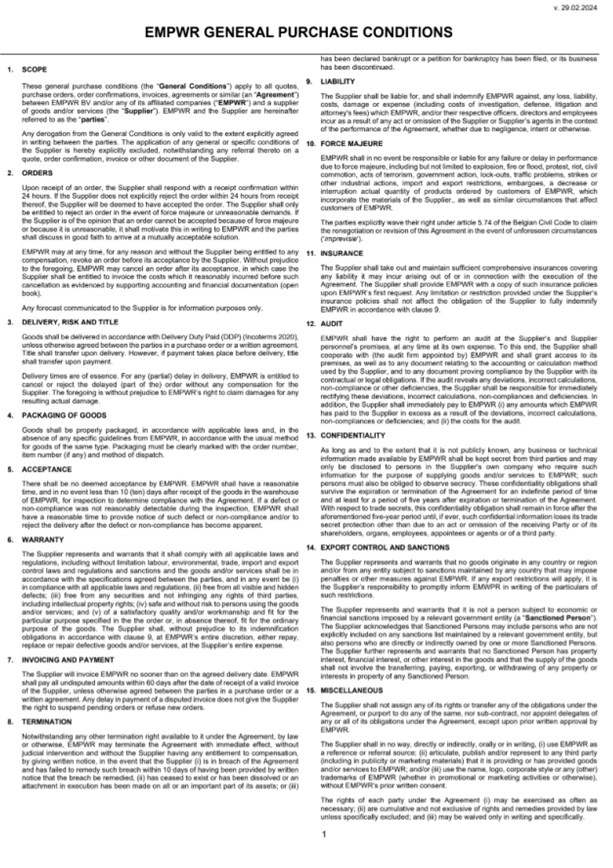
Terms & Conditions

